NAME: TEJAS NALAWADE PRACTICAL NO: 4 ROLL NO: TCOD01
Implement PL/SQL Code block for given requirements.
Consider Tables:
1. Borrower(Roll_no, Name, Date of Issue, Name of Book, Status)
2. Fine(Roll_no, Date, Amt)
• Accept Roll_no and Name of Book from user.
• Check the number of days (from date of issue).
• If days are between 15 to 30 then fine amount will be Rs 5 per day.
• If no.of days>30, per day fine will be Rs50 per day and for days less than 30, Rs.5 per day.

b. Write at least 10 SQL queries on the suitable database application using SQL DML statements.
DATABASE

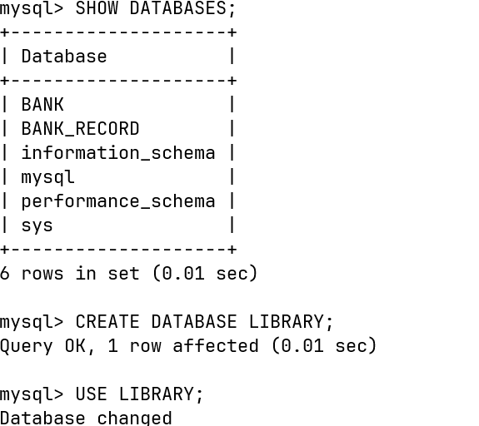

TABLES

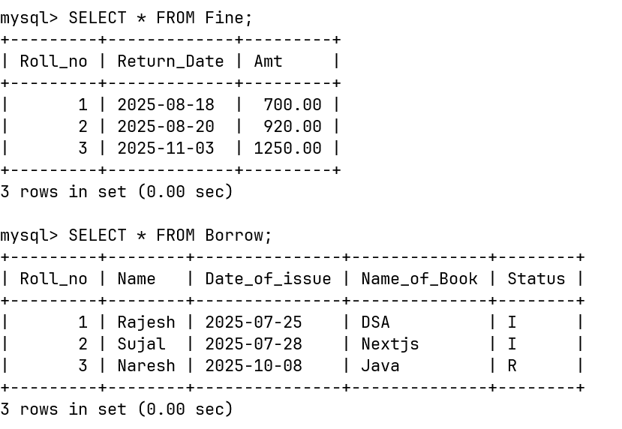

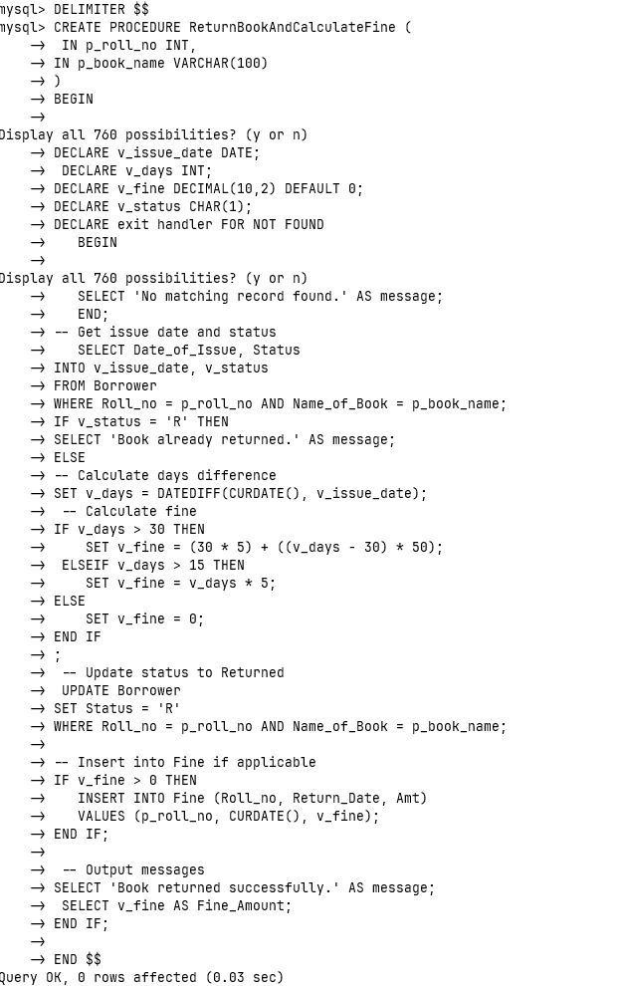
PROCUDURE

CALL

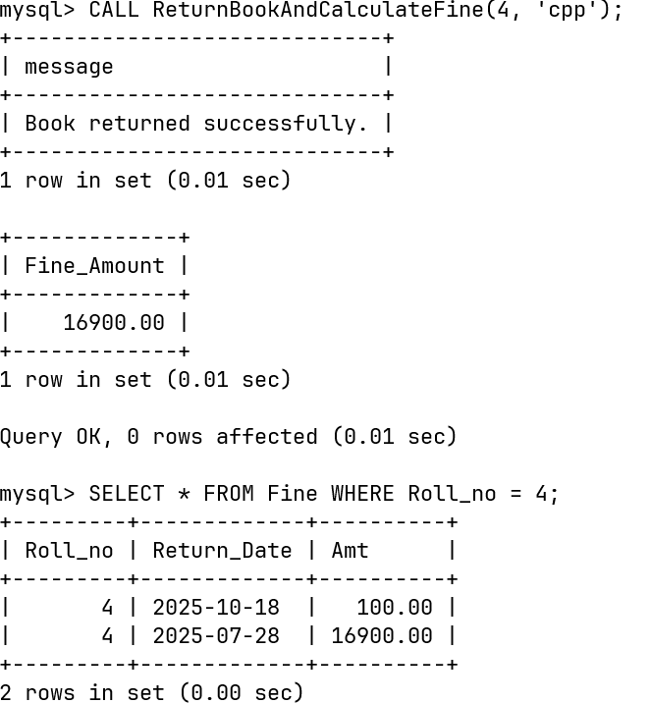

FINAL STATUS

